cv
ANDREA G. BRAVO
PhD in Environmental Sciences
Born: 1982 (Spain)
h-index: 14
Citations: 715
m@il: jandriugarcia@gmail.com
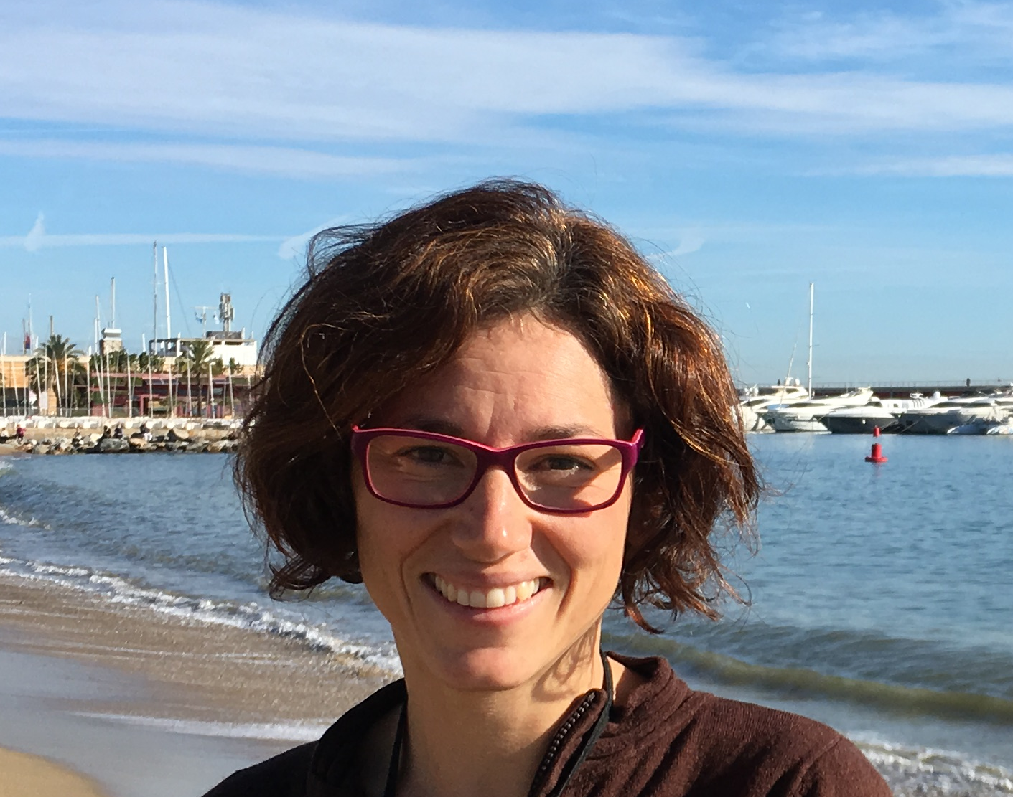
webpage: https://agbravo.weebly.com/

RESEARCH INTERESTS: Ecology of pollutants
My main research interest is the fate of pollutants in the environment with a special emphasis on mercury biogeochemistry in rivers, lakes, ponds, wetlands, soils and the ocean. More specifically, I focused on the processes controlling the concentration of methylmercury in the landscape and its further biomagnification in food chains.

CURRENT POSITION
From 09/2018 Institute of Marine Sciences, Spanish Research Council (ICM – CSIC). Spain.
Marie Skłodowska-Curie Individual Fellowship. European Commission.
EDUCATION
2006 – 2010 PhD in Environmental Sciences. Geneva University, Institut F.A. Forel, Switzerland.
“Mercury methylation and trophic transfer in freshwater systems”. Supervisors: Janusz Dominik and Walter Wildi.
2004 – 2005 DEA in Environmental Sciences: Universidad Autónoma de Madrid, Spain.
2000 – 2004 Bachelor degree in Environmental Sciences. Universidad Autónoma de Madrid, Spain.
PREVIOUS POSITIONS
07/2017 – 08/2018 Postdoctoral Researcher at the Institute of Environmental Assessment and Water Research, Spanish Research Council (IDAEA-CSIC). Spain
Beatriu de Pinós Grant to Andrea G. Bravo. Agency for Management of University and Research Grants – AGAUR. Generalitat de Catalunya.
12/2016 – 03/2017 Researcher at Umeå University, Sweden.
04/2014 – 11/2016 Researcher at Uppsala University, Sweden.
03/2012 – 03/2014 Postdoctoral Researcher at Uppsala University.
Grant to Andrea G. Bravo by Swedish Research Council.
01/2011 – 09/2011 Postdoctoral Researcher at Geneva University, Institut F.A. Forel, Switzerland.
06/2005 – 09/2011 Research assistant position in Geneva University, Institut F.A. Forel, Switzerland.
HIGHLIGHTED PEER-REVIEWED PUBLICATIONS
A total of 35 peer-reviewed publication with 13 as first author, 5 as second author and 5 as last and group-leader and corresponding author. 5 Highlighted publications:
A. G. Bravo, D. N. Kothawala, K. Attermeyer, E. Tessier, P. Bodmer et al. 2018. The interplay between total mercury, methylmercury and dissolved organic matter in fluvial systems: A latitudinal study across Europe. Water Research 144, 172–182.
A. G. Bravo, J. Zopfi, S. Bertilsson, J. Xu, M. Buck, J. Pote, C. Cosio. 2018. Geobacteraceae are important members of mercury-methylating microbial communities of sediments impacted by waste water releases. The ISME journal 12:802–812.
S. Herrero, N. Catalán, H. Gröntoft, T. G Hilmarsson, S Bertilsson, P. Wu, K. Bishop, O. Levanoni, E. Björn, A. G. Bravo. 2018. High methylmercury formation in ponds fueled by fresh humic and algal derived organic matter. Limnology & Oceanography 63, 44-53.
A. G. Bravo, S. Bouchet, J. Tolu, E. Björn, A. Mateos-Rivera, S. Bertilsson. 2017. Molecular composition of organic matter controls methylmercury formation in lakes. Nature Communications 8, 14255.
E. Gascón Díez, J-L. Loizeau, C. Cosio, S. Bouchet, T. Adatte, D. Amouroux, A. G. Bravo. 2016. Role of settling particles on mercury methylation in the oxic water column of freshwater systems. Environmental Science & Technology 50 (21), 11672-11679.

AWARDS
- 2019: Raymond L. Lindeman Award to recognize an outstanding paper written by a young aquatic scientist of the Association for the Sciences of Limnology and Oceanography (ASLO). The publication awarded is Bravo et al., (2017): Molecular composition of organic matter controls methylmercury formation in lakes. Nature Communications 8, 14255.
- 2013: The Foundation of King Carl XVI Gustaf's 50th Anniversary Fund for Science, Technology and Environment. Amount: 85 000 SEK (~10 000€).
TEACHING AND STUDENTS SUPERVISION
- Courses, laboratory and workshops (a total of 65 ECTS):
- PhD supervision (2):
  - Jingying Xu (2018). Remediation of mercury contaminated soil and biological mercury methylation in the landscape. Uppsala University.
  - Baolin Wang (ongoing). Microbial mercury methylation along a chronosequence of boreal peatlands. Uppsala University.
- Masters supervision (10): Marina Pérez-García (2018, University of Barcelona and ICM-CSIC), Torfi-Geir Hilmarsson (2015, Uppsala University), Hannes Gröntoft (2015, Uppsala University), Sonia Herrero Ortega (2015, Uppsala University), Alejandro Mateos Rivera (2014, Uppsala University), Anastasija Isidirova (2013, Uppsala University), Clément Roy (2011, Geneva University), Christine Picard (2008, Geneva University), Lydie Ancey (2008, Geneva University).

EVALUATION AND REFEREE RESPONSABILITIES
- 2018. Fonds de Recherche Nature et Technologie (Canada)
- 2018. Natural Sciences and Engineering Research Council of Canada (NSERC, Canada)
- 2018. Czech Science Foundation (Czech Republic)
- 2016. National Science Foundation (EEUU)
- 2017. Energy Environment Solutions Programme (France)

SERVICES
- 2014-2019: Workshops and special sessions in international meetings
- 2018. Secretary of the Iberian Society of Ecology (SIBECOL).
- 2018. Member of the communication board of the Iberian Society of Ecology (SIBECOL).
- 2018. Board member of the Iberian Association of Limnology (AIL).
- 2018. In charge of the webpage of the Iberian Association of Limnology (AIL).

